Decent rate:

Faa.gov. “Instrument Procedures Handbook (IPH) | Federal Aviation Administration,” 2022. <https://www.faa.gov/regulations_policies/handbooks_manuals/aviation/instrument_procedures_handbook>.

M = 0.76 (avg) = 260.68 m/s

T_f = 920 sec = 15.349 min

For normal category and commuter category airplanes, from −1.52 to +3.8

<http://rgl.faa.gov/Regulatory_and_Guidance_Library%5CrgFAR.nsf/0/D35E170180C8CB2185256687006D0C90?OpenDocument>

Boeing 737 specs

<https://modernairliners.com/boeing-737/boeing-737-specifications/>

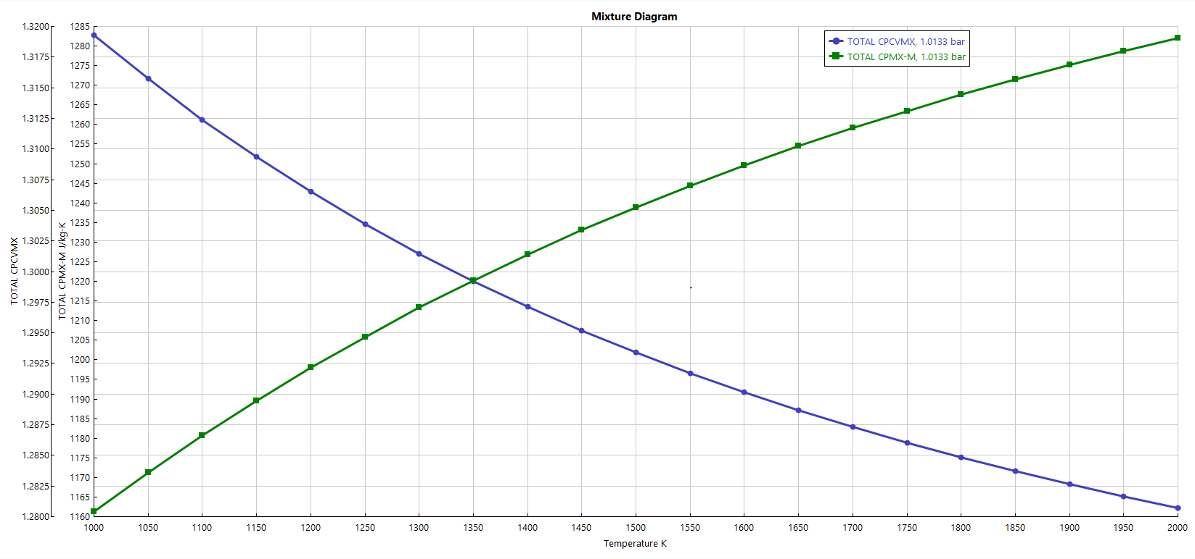

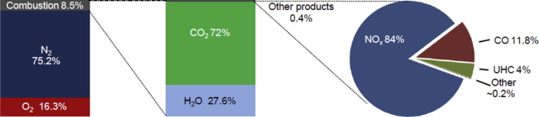

<https://www.ncbi.nlm.nih.gov/pmc/articles/PMC7108289/>

<https://modernairliners.com/airbus-a320-introduction/airbus-a320-specs/>